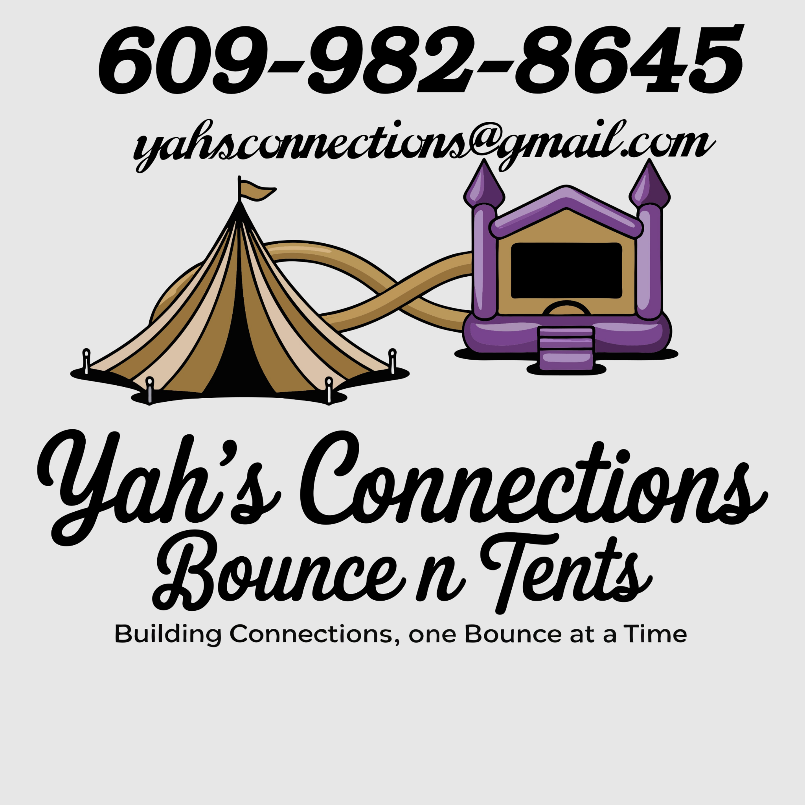
Bounce House Safety Rules & Liability Waiver

Name: _______________________________
Event Date: ____________________
Location: _______________________________
_______________________________________

Safety Rules – MUST BE FOLLOWED
Adult supervision is required at ALL times.
No shoes, food, drinks, or sharp objects in the bounce house.
No flips, wrestling, or rough play.
Do not exceed the maximum number of children allowed at once.
Keep children of different sizes/ages separate to avoid injury.
Do not use equipment in high winds, rain, or unsafe conditions.
Liability Waiver

I understand that participation in bounce houses and inflatable activities carries risk of injury. By signing below, I assume all risks of injury or accident.
I release and hold harmless Yah’s Connections Bounce N Tents, its owners, staff, and affiliates from any liability, claims, or damages.
Accept responsibility for supervising children in my care.
Acknowledgment
I have read, understand, and agree to the above rules and waiver.

Printed Name (Parent/Guardian): _______________________________
Signature: _______________________________Date: ____________________
Phone Number: ____________________

